Digital Marketing

Table of Contents
1.0 Introduction 3
1.1 Using Social Impact Theory 3
1.1 Social media presence 4
1.2 Competitive landscape 5
1.3 Preferences and behaviours of target audience 5
2.0 Content strategy for engagement 6
2.1 Example posts for engagement 7
2.2 Critical assessment of content strategy 8
3.0 Digital Marketing Analytics 9
3.1 Key Analytics 9
3.2 Tweaks to Content Plan 9
3.3 Risks of Content Tweaks 10
4.0 References 11
5.0 Appendices 12
Appendix 1 12
Appendix 2 16

1.0 Introduction
Contemporarily, the use of technology is at its apex as a result of which businesses are now incorporating the same in their processes. As a result of this digital era, content planning has become excessively important and is being paid heed to accordingly. In order to compete in markets where cut-throat competition exists, organizations are designing content to connect with the masses and differentiate themselves from the offerings in the market. Social media has inevitably taken over and in order to emulate organizations are gearing their strategies and tailoring them around different theories that are mentioned as follows.

1.1 Using Social Impact Theory
According to Naylor et al (2012), social impact theory signifies that when other people are considered as the influential, the impact is relevant, manipulative, immediate, and can attract a number of people thereafter making it possible for the business to burgeon. Similarly, Kwahk and Ge (2012) averred that as the number of people increases, the influence on target audiences is highly augmented as it imposes a direct impact on their behavior and attitude. Referring to social media sites, for instance, users on Facebook share specific information regarding a product/service, as they share experiences/information, the impact on the targeted individuals is likely to be increased (Edosomwan et al., 2011).
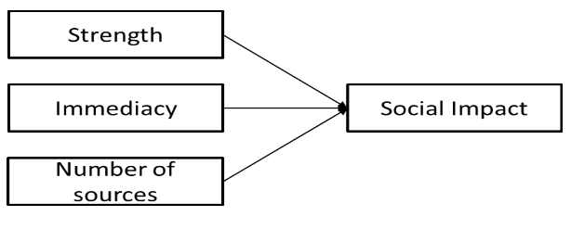
Figure 1: Social Impact Theory (Naylor et al., 2012)
In case of Trespass that is one of the leading online UK-based outdoor activewear retailers, the SMART goals have been created in order to increase the number of referrals from social media sites to Trespass website from 150 to 300 within 1 week. To accomplish the set SMART goal, while keeping in consideration target audiences, the engagement strategy for Trespass will be based on two social media channels that include Facebook and Twitter.
By gaining the insights from Facebook page and Twitter of Trespass (refer to appendix 1), there are very fewer likes on the posts shared by Trespass. There is a lack of focus there too, and also it is noted that there is no video being posted on the Facebook fan page. There are no video posts, as mentioned by Biteable (2019), video content is eye-catching and receives the most views. Moreover, as averred people are 1.5 times more likely to watch the videos on their phone, this gives the opportunity to Trespass to grab the attention of its targeted audiences. It is highly recommended that the videos to be posted on the fan pages so that it will increase the number of referrals to the website. Sharing of post on several related pages and by users will boost up the likes and will augment directly to consumers (target audience) of Trespass (Edosomwan et al., 2011). Video should be created by interviewing consumers and asking them to describe Trespass in 1 word and share experiences. This when shared by users, will result in social immediacy as the number of share of post will eventually be reached to the targeted audiences of Trespass. As a result, website traffic will increase.

Social media presence
The table below explains the social media sites selected for Trespass to know the number of followers and the frequency of the activity being done.
Social media site | URL | Followers | Last Activity date
Facebook   | https://www.facebook.com/trespass/ | 26727(Followers)  27230 (Likes) | February 19, 2019
Twitter   | https://twitter.com/Trespass | 14.3k followers | February 15, 2019

In case of Trespass, the consumers are the main target, as per SIT and relevancy of the message, temporal immediacy matters a lot (Power & Phillips-Wren, 2011). The timing and duration matter most, however, Trespass will post on specific time durations but every time a new post will be posted so that the message could be reached to right target audiences.

Competitive landscape
Brands | Social profile | Strengths | Weaknesses
Competitor #1: Go Outdoors UK   | Facebook  Twitter (Refer to appendix 2) | A large number of followers on Facebook and also possess strong product portfolio  A strong presence on social media  No of Likes on FaceBook/Twitter:199,310/9743 | Minimal market expansion
Trespass   | Facebook  Twitter | Trespass is leading UK’s active by its USPs and cost-effectiveness.  No of Likes on Facebook: 27230 | Low website traffic  Lack of focus on fan pages like Facebook and Twitter
Competitor # 2:  Cotswold Outdoor UK   | Facebook  Twitter | Number of likes on Facebook/Twitter= 84,925/9247  Highly recognized  Offers competitive pricing  Recommended retailer for Duke of Edinburgh Award scheme. | Lack of attention on social media  The posts are no updated timely  Last post was on 7th January.

Preferences and behaviours of target audience
The target market in case of Trespass is the consumer that includes men, women, boys, and girls. They offer products for all age groups. These are the people that are busy in daily errands, like going to universities, also includes workaholics men and women etc so by looking onto the fields and their business, they would want their preferred brands to be just a click away. So for Trespass, the social media executive should be available 24/7 (Power & Phillips-Wren, 2011). The queries when shared on Facebook or Twitter fan page should be responded timely without being late. The constant post on Facebook and Twitter will include sharing of information regarding the sales and any promotions that will directly take the audiences to the website which as a result it will increase the number of referrals (Mangold & Faulds, 2009). By building a strong online platform where the target audience can browse the Trespass product line and have any queries answered, the strategy can help lure more people into checking the company website (Frick, 2013).

2.0 Content strategy for engagement
In the world of digital marketing, there is no universal template for building a successful strategy. However, for a business like Trespass, a few things need to be kept in mind. Firstly, the strategy should detail what its target audience needs, and how it can provide them with the ease of executing their adventurous plans (Rockley & Manning, 2003). The two social media channels used for this strategy are Twitter and Facebook, the reasons for choosing these two can be better explained through the honeycomb model;
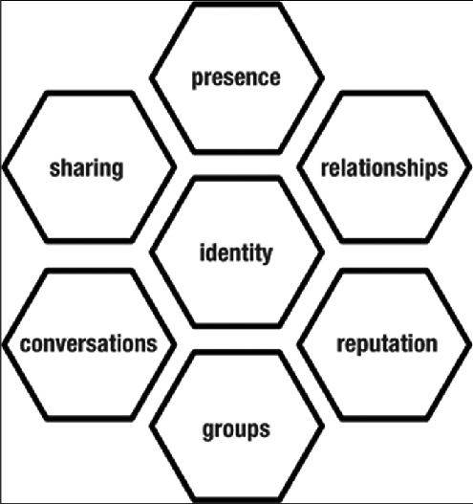
Figure 2: Honey Comb Model (Knutson & Tao, 1999)
Looking at this model, it can be seen that Facebook and Twitter provide its users with all 7 of these facets. Social media presence can be seen by looking at users’ online posts, as well as looking at their online status on Facebook. Users also relate to each other through “sharing” and “retweeting” of posts. Users communicate with each other through private messages as well as in the comments section, which can also help Trespass engage with its consumers (Burton, 2011). Therefore, these two social networks can help Trespass identify its target market, as well as show them what its identity is and what it stands for.
The company pages would be utilized through posts marketing the product line, as well as posts about brand ambassadors and motivational pictures and quotes which would be relatable to the target audience and entice users to share them to their friends. Posts would be in the form of text, pictures and videos of sports athletes, and an emphasis on hashtags would help attract an audience interested in what the company represents (Frick, 2013). The pages should also be keen on sharing blog posts that are both informative and promote the products Trespass provides. Apart from that, posts encouraging consumers of the products to share pictures of them wearing the gear should be made, which would then be posted on the page as a means to provide testimonials.

2.1 Example posts for engagement
The posts shared can be as follows:
“There is no better feeling than to watch the sunset and drink a hot cup of coffee after a hiking trip. Trespass helps you connect with nature. #GoFurther”
A post like this should be accompanied by attractive scenery of the outdoors, one that makes the viewer feel the urge to discover the world. Nature is beautiful, and the post should remind the audience of that.
Example of posts can be further explained by looking at a current post made by Trespass:
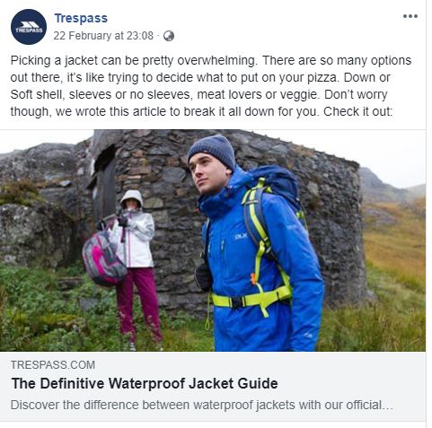
The post hits almost all the right marks, but there is still some room for improvement. Firstly, the caption accompanying the link should be smaller. People browsing through social media may not want to read overly long captions, which would detract the customers from clicking the link. The overly long caption also seems too devised and corporate (Frick, 2013). Social media users would respond more positively if the caption did not read like sales pitches, but instead almost like a friend trying to help. With that being said, the idea of comparing a product with food items is commendable, as it is both humorous and relatable to a large chunk of the audience. This is something that would stay consistent in the content strategy.

2.2 Critical assessment of content strategy
The content strategy shared above is direct, inclusive and gives Trespass a good chance at achieving the short-term goal they have of increasing their social media presence (Holliman & Rowley, 2014). The points made in the strategy can be backed up by looking at the Social Impact Theory, which states that strength, immediacy and number of sources must be focused on in order to create a substantial presence in the social networks.
As Trespass is already a reputable source of outdoor gear, it should not be difficult to emphasize on its strength in the market through Facebook and Twitter. The company has an advantage in the strength category, given that it is a market expert (Bulearca & Bulearca, 2010). To further improve on this aspect, Trespass will also utilize its brand ambassadors, about whom posts, pictures and quotes would be shared. When it comes to Immediacy, posts should be regular and consistent. There should be a target of at least one post per day, so that the posts are often, but not overbearing and do not clog the audiences news feed all the time. Furthermore, private messages to the group should be answered in a quick manner, and the potential customer is not made to wait (Evans, 2010). Lastly, the number of sources, Facebook and Twitter, are two of the largest social media networks of the world, and people that would generally be interested in outdoor gear would likely be present on these websites, which is what makes them ideal for the strategy. Moving on to the Information Quality Theory, the strategy noted above is, for the most part, sound and usable. However, due to the ever-evolving trends of social media, there are rarely any strategies that can be classified as dependable. Therefore, the strategy should be flexible and should be changed in case there isn’t the sort of response that is expected.

3.0 Digital Marketing Analytics

3.1 Key Analytics
For Facebook, the key source for statistics regarding engagement by likers and commenters is Facebook analytics. This website allows pages to see where and how people interact with the page, what channels they are using in order to reach the page, and also gives data in order to target consumers who are most interested in the content that is being provided. All of this is done in an anonymous way, so that the customers do not feel as though their privacy is being exploited (Jayaram et al., 2015). The same goes for Twitter, which has Twitter Analytics, a service that allows users to see which tweet got the most engagements, and what do followers care most about. These two sources can give the company a way of understanding what part of the strategy works and what should be focused less on, as well as a better ROI (Frick, 2013).

3.2 Tweaks to Content Plan
As mentioned before, the trends of social media networks are ever-evolving. What is popular now may not be so in the future. Therefore, it is essential for any content strategy to be diverse and have a willingness to change in case the results are not what were expected. When looking at the Social Impact Theory, the strength of Trespass may be high, but its social media reach is not as large as some competitors (Holliman & Rowley, 2014). Therefore, if its current likers aren’t engaging with the same level of enthusiasm as expected, then a part of the budget should be allotted to promoted posts and tweets, so that there can be a larger reach. Furthermore, there is also a chance for the message being portrayed by the posts to be misinterpreted. In any such case, the social media team should be ready to implement damage control, and change the content it posts to appease the audience (Jayaram et al., 2015).

3.3 Risks of Content Tweaks
With any marketing strategy trying to increase its customer base, there is always a risk involved. The same goes for Trespass content strategy. By the looks of it, Trespass already has a sturdy and consistent strategy and the one mentioned above is not critical in its changes. However, there needs to be a step forward if it wants to see the results it desires (Bulearca & Bulearca, 2010). This, however, can lead to downsides. For example, content marketing is rewarding, but it is also time-consuming. If the strategy is not implemented with diligence and consistency, then all the effort and money invested would go to waste. Secondly, there is a chance of brand inconsistency. If content is rapidly produced for many channels without a content governance system in place, it can damage your brand through inconsistency (Rockley & Manning, 2003). Content irrelevancy can also cause the wrong message to be delivered, and would not give the followers posts that are relevant to their interests. If any of these risks come to life, then that could mean that the loss of consumers that were already loyal to the Trespass brand.

4.0 References
- Biteable, 2019. Video making statistics for 2019. [Online] Available at: https://biteable.com/blog/tips/video-marketing-statistics/ [Accessed 20 February 2019].
- Bulearca, M. & Bulearca, S.., 2010. Twitter: a viable marketing tool for SMEs? Global business and management research, 2(4), p.296.
- Burton, S.a.S.A., 2011. Interactive or reactive? Marketing with Twitter.. Journal of Consumer Marketing, 28(7), pp.491-99.
- Edosomwan, S. et al., 2011. The history of social media and its impact on business. Journal of Applied Management and entrepreneurship, 16(3), pp.79-91.
- Evans, L.L.., 2010. Social media marketing: strategies for engaging in Facebook, Twitter & other social media. India: Pearson Education India.
- Frick, T.., 2013. Return on engagement: Content, strategy and design techniques for digital marketing. UK: Focal Press.
- Holliman, G. & Rowley, J., 2014. Business to business digital content marketing: marketers’ perceptions of best practice. Journal of research in interactive marketing, 8(4), pp.269-93.
- Jayaram, D., Manrai, A.K. & Manrai., L.A., 2015. Effective use of marketing technology in Eastern Europe: Web analytics, social media, customer analytics, digital campaigns and mobile applications. Journal of Economics, Finance and Administrative , 20(39), pp.118-32.
- Knutson, A. & Tao, T., 1999. Honey Comb Model. Journal of the American Mathematical Society, 12(4), pp.1055-90.
- Kwahk, K.Y. & Ge, X., 2012. The effects of social media on e-commerce: A perspective of social impact theory. In In 2012 45th Hawaii International Conference on System Sciences. USA, 2012.
- Mangold, W.G. & Faulds, D.J., 2009. Social media: The new hybrid element of the promotion mix.. Business horizons, 52(4), pp.357-365.
- Naylor, R.W., Lamberton, C.P. & West, P.M., 2012. Beyond the “like” button: The impact of mere virtual presence on brand evaluations and purchase intentions in social media settings. Journal of Marketing, 76(6), pp.105-20.
- Power, D.J. & Phillips-Wren, G., 2011. Impact of social media and Web 2.0 on decision-making. Journal of decision systems, 20(3), pp.249-261.
- Rockley, A..K.P. & Manning, S., 2003. Managing enterprise content: A unified content strategy. London: New Riders.

5.0 Appendices

Appendix 1
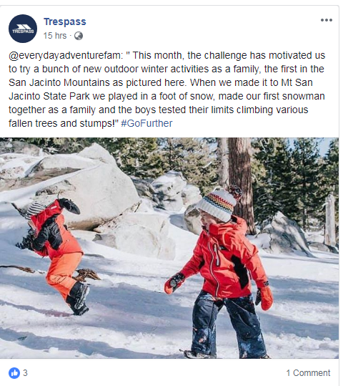
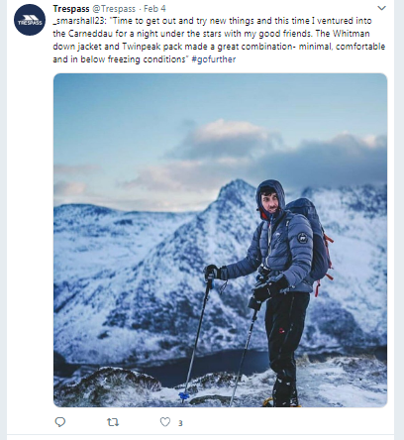

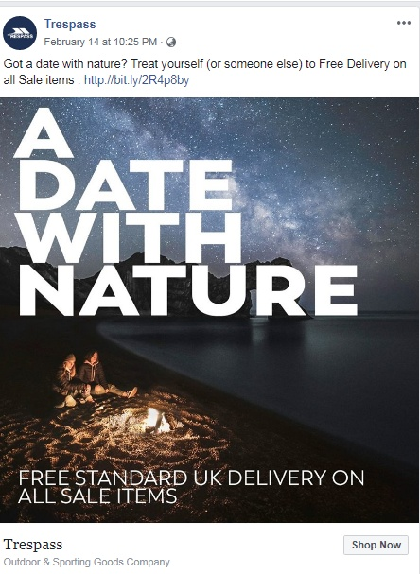

Appendix 2
